**EIT scales-up support for innovators across Europe in 2020**

**News 04/12/2019**

[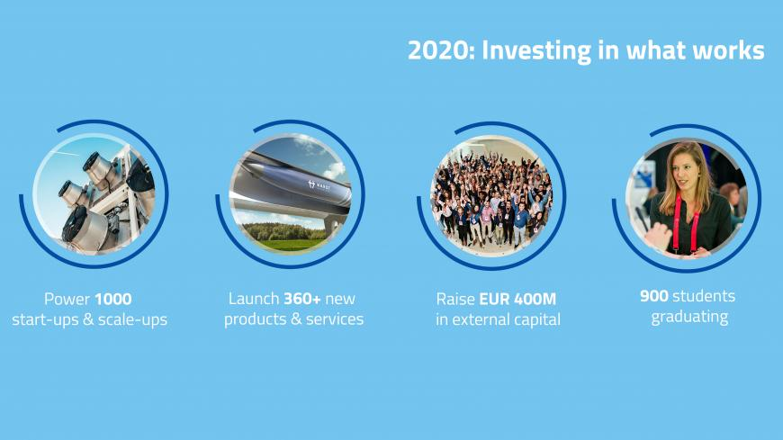](https://eit.europa.eu/sites/default/files/investing-website.jpg)

**In 2020, the**[**European Institute of Innovation & Technology (EIT)**](https://eit.europa.eu/)**will invest EUR 500 million in its Knowledge and Innovation Communities across Europe – the EIT Governing Board decided.**

**This investment will drive European innovation in the areas of climate (**[**EIT Climate-KIC**](https://www.climate-kic.org/)**), digitisation (**[**EIT Digital**](https://www.eitdigital.eu/)**), food (**[**EIT Food**](https://www.eitfood.eu/)**), health (**[**EIT Health**](https://www.eithealth.eu/)**), sustainable energy (**[**EIT InnoEnergy**](http://www.innoenergy.com/)**), advanced and sustainable materials (**[**EIT RawMaterials**](https://eitrawmaterials.eu/)**), manufacturing (**[**EIT Manufacturing**](http://eitmanufacturing.eu/)**) and urban mobility (**[**EIT Urban Mobility**](https://www.eiturbanmobility.eu/)**).**

[Download as a PDF](https://eit.europa.eu/sites/default/files/2019-12-04_pr_eit_2020_investment_final.pdf)

The EIT’s eight Knowledge and Innovation Communities competed for **EUR 500 million** and were evaluated against their strategies and business plans for 2020, as well as their performance to date. Based on this, the EIT Governing Board decided to allocate the following grants  (in order of their selection in 2009, 2014, 2016, and 2018*):

[**EIT Climate-KIC**](https://www.climate-kic.org/)**: EUR 78.4 million**

[**EIT Digital**](https://www.eitdigital.eu/)**: EUR 66.2 million**

[**EIT InnoEnergy**](https://www.innoenergy.com/)**: EUR 77.8 million**

[**EIT Health**](https://www.eithealth.eu/)**: EUR 85.1 million**

[**EIT Raw Materials**](https://eitrawmaterials.eu/)**: EUR 81.7 million**

[**EIT Food**](https://www.eitfood.eu/)**: EUR 55.1 million**

[**EIT Manufacturing**](http://eitmanufacturing.eu/)**: EUR 26.8 million**

[**EIT Urban Mobility**](https://www.eiturbanmobility.eu/)**: EUR 28.8 million**

The EIT Governing Board also decided to allocate **EUR 30 million** to the [EIT Regional Innovation Scheme (EIT RIS)](https://eit.europa.eu/our-activities/eit-regional-innovation-scheme-ris) - the programme that helps modest and moderate regions (according to the European Innovation Scoreboard) to fully realise their innovation potential through the sharing of good practice and experience from across the EIT Community. The EIT RIS fund will be available to all EIT Innovation Communities that include EIT RIS eligible activities in their 2020 Business Plans. The EIT Governing Board also decided to allocate EUR 12.5 million for joint activities between Knowledge and Innovation Communities, for example, in the areas of artificial intelligence and Skills 4 Future.

In addition, the EIT Governing Board put in place a Task Force on enhancing innovation and entrepreneurship in higher education institutions, in preparation for the EIT’s role in [Horizon Europe](https://ec.europa.eu/info/horizon-europe-next-research-and-innovation-framework-programme_en). The Task Force will be chaired by [Patrick Prendergast](https://eit.europa.eu/who-we-are/governing-board/meet-gb), Member of the EIT Governing Board, and will include representatives of the European Commission (DG EAC).

[**Dirk Jan van den Berg**](https://eit.europa.eu/eit-community/eit-governing-board/meet-gb), Chairman of the EIT Governing Board, said: *'I am very pleased to see the progress in the past year which is strongly based on the focused stewardship of the EIT’s Governing Board. It is crucial that the opportunities for innovators, the EIT community offers, are scaled-up across the whole of Europe. Why? This investment is not just to create another product, or power another start-up; it’s to bring about the urgent need for more innovative European solutions at a much larger scale, to tackle pressing societal challenges.’*

**Martin Kern**, [EIT Director](http://eit.europa.eu/eit-community/eit-headquarters/director), added: *'The EIT is now Europe’s proven innovation engine and 2020 will see strong impact from our eight Knowledge and Innovation Communities, based on their submitted plans. Our results clearly show that the EIT’s investment delivers and turns ground-breaking ideas into products and services for a greener, healthier, more sustainable Europe. We particularly look forward to scaling up our support for innovators and entrepreneurs in countries where EIT Knowledge and Innovation Communities have a limited presence. I would like to thank the EIT Governing Board Members for their strong strategic steering of the EIT community.*'

**Investing in what works**

The 2020 funding will step up activities for [entrepreneurs](https://eit.europa.eu/our-activities/entrepreneurship)**,**[innovators](https://eit.europa.eu/our-activities/innovation), [and students](https://eit.europa.eu/our-activities/education)**,**including business creation and acceleration services, entrepreneurial educational programmes and innovation-driven research projects. These activities have been shown to work, delivering tangible impact for Europe. In 2020, the EIT Community plans to **power 1000 start-ups and scale-ups** and launch more than**360 new products and services**to contribute to Europe’s efforts of tackling global challenges. More than**900 students**are expected to graduate from EIT labelled master and doctoral programmes, strengthening the pool of talented and entrepreneurially-minded change agents eager to transform their best ideas into solutions for Europe. It is foreseen that in 2020 alone, ventures supported by the EIT-Community will raise **over EUR 400 million in external capital**.

Since the EIT was set up in 2008, it has created Europe’s largest innovation community, with **more than 1 000 partners**and**50 innovation hubs**. This has delivered support to more than **2 000 start-ups and scale-ups**, created more than **6 100 jobs** and more than **900 new products and services**. More than **2 200 students** have graduated from EIT-labelled master and doctoral programmes. To date, EIT-supported ventures have raised more than **EUR 1.5 billion in external capital.**